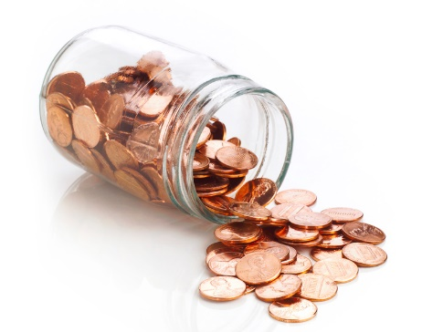
A Penny for Your Thoughts
Pamela Consuegra, PhD

“What is the price of two sparrows—one copper coin? But not a single sparrow can fall to the ground without your Father knowing it. And the very hairs on your head are all numbered. So, don’t be afraid; you are more valuable to God than a whole flock of sparrows.” Matthew 10: 29-31 (NLT)

- Without looking at one, write down everything you know about a penny. ________________________________________________________________________________________________________________________________________________

- Now, look at a penny and add what you missed. ________________________________________________________________________________________________________________________________________________

- In Bible times, a sparrow was worth ______________________________________.

- The average penny lasts ____________ years!

- Pennies were the very first coins minted in the United States in _____________.

- There have been ______________ different designs featured on the penny.

- The Lincoln penny was first minted and circulated in 1909, the 100th anniversary of his birth.

- Lincoln faces to the _________ , while all other portraits on coins face to the ________.

- In a coin toss, always choose _______________!

- The penny was the first U.S. coin to have the motto ______________________.

- Approximately ________ pennies per day (_______ pennies every second) are produced.

- Over ____________ of all coins produced by the U.S. Mint are pennies.

- More than ____________ of Americans support keeping the penny.

- How might understanding the value of 936 pennies impact our parenting? ________________________________________________________________________________________________________________________________________________________________________________________________________________________________________________________________________________________________

